Промежуточная контрольная работа за 1 полугодие
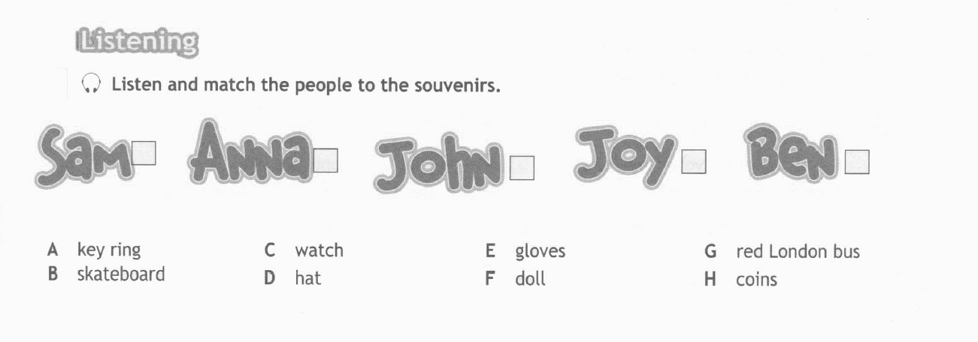
5 класс (базовый уровень)
1.
2. Readthetext. Underline the correct words in the sentences below.
Hello James!
How are you? My name is David and I am eleven years old. I go to Green School. I am in 5th form. Usually the lessons start at 9:00 a.m., but on Saturdays they start at 9:15 a.m. We study a lot of subjects but my favourite subject is PE. I also like History and English. I have a lunch break from 12:30 to 1:30 every day. My favourite day at school is Friday. I have History, PE and English on this day.
Well, that’s about it.
Please, write soon and tell me about your school.
Bye for now.
David

1) David is 11/12 years old.
2) On Saturday the lessons start at nine fifteen/ nine o’clock.
3) David goes to Yellow/ Green school.
4) His favorite subject is Information Technology/Physical Education.
5) He likes Science and Maths/English and History too.
6) David starts lunch at 12:30/1:30.
7) His favourite day at school is Friday/Thursday.

- Choose the odd word.
- yellow – green – grey – nine – black – white
- Geography – History – Canada – English – Music – Art
- pencil – eraser – ruler – write – pen – crayons
- thirteen- twelve-eleven- fifteen-seventeen-two

- Complete with is / are/ am
- Susan __ new to the school.
- I ____ 14 years old.
- They ___ in Room E.
- He ___ my best friend.
- You __ in grade 7.

5. Choose the right nationality
1.The UK – a)British b) American c)Canadian
2. Canada – a)Australian b)Canadian c) French
3. Australia – a) New Zealander b) Australian c) British

6. Underline the correct item.
1) Bob have/has got blue school bag.
2) We has/have got basketballs.
3) They has/have got pens and pencils.
4) Natasha have/has got a cap and gloves.
5) Peter has/have got special powers.

- Choose the right word in plural.
- Child – a) childs b) children
- Man – a)men b)mans
- Box – a)boxes b)boxez
- Leaf – a)leaves b)leafs
- Party – a)parties b) partys
- Boy – a) boies b)boys

8. Fill in : is, are
- There….. five chairs.
- There… a table.
- There… two windows.
- There… a fireplace.
- There… no carpets.
9. Choose the right number
1. 40 – a)forty b) fourteen c) fourty
2. 95 – a)ninety – fife b) ninety- fifth c) ninety – five
3. 38 – a) thirty – eight b)thirty – eihgt c) thirteen – eight
4. 100 – a) a hundred b) a hundreds c) one hundreds

Рекомендуемые критерии оценивания:
Раздел 1: аудирование | Макс.балл – 5 | Итого:  Максимальный балл за работу - 44
Раздел 2: чтение | Макс.балл – 7 | Итого:  Максимальный балл за работу - 44
Раздел 3: Лексика и грамматика | Макс.балл – 32 | Итого:  Максимальный балл за работу - 44

Оценка «5» отлично | 39-44 баллов
Оценка «4» хорошо | 33-38 баллов
Оценка «3» удовлетворительно | 22-32 баллов

